# 2012 ACME Standup LP Grill

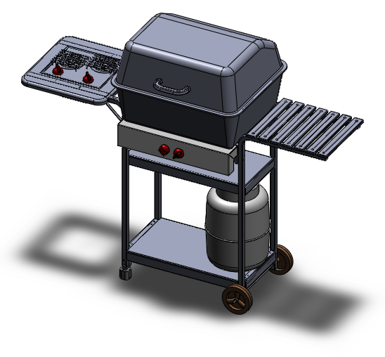

Frame Sub-Assembly

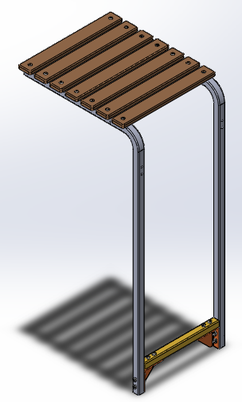

Frame Exploded View Detail

|  |  |  |
| --- | --- | --- |
|  |  |  |
|  |  | |